|  |  |
| --- | --- |
| Course Name | ITD 2313 – Script Programming |
| Instructor | Greg Morris |
| Student Name | Mung Mang |
| Due date | 02/02/2023 |
| Grade | Put grade earned here |
| Grading Comments | Put instructor comments here |

Pg 65, 66

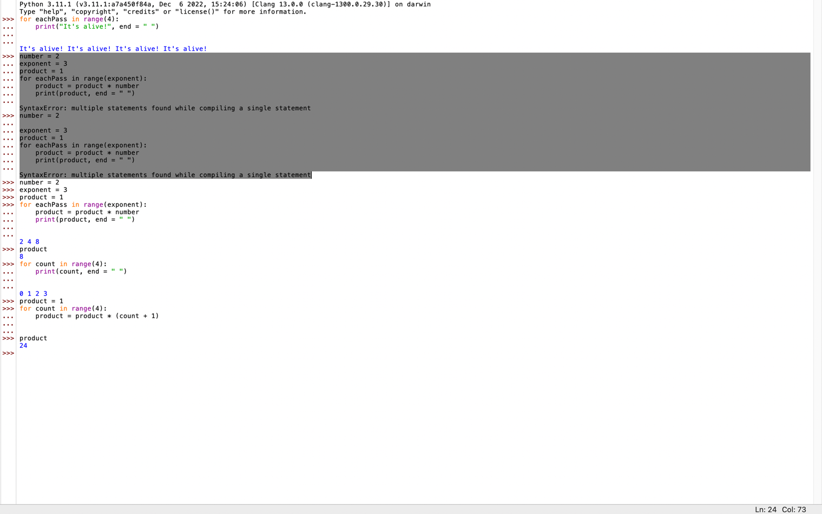

Pg 67.

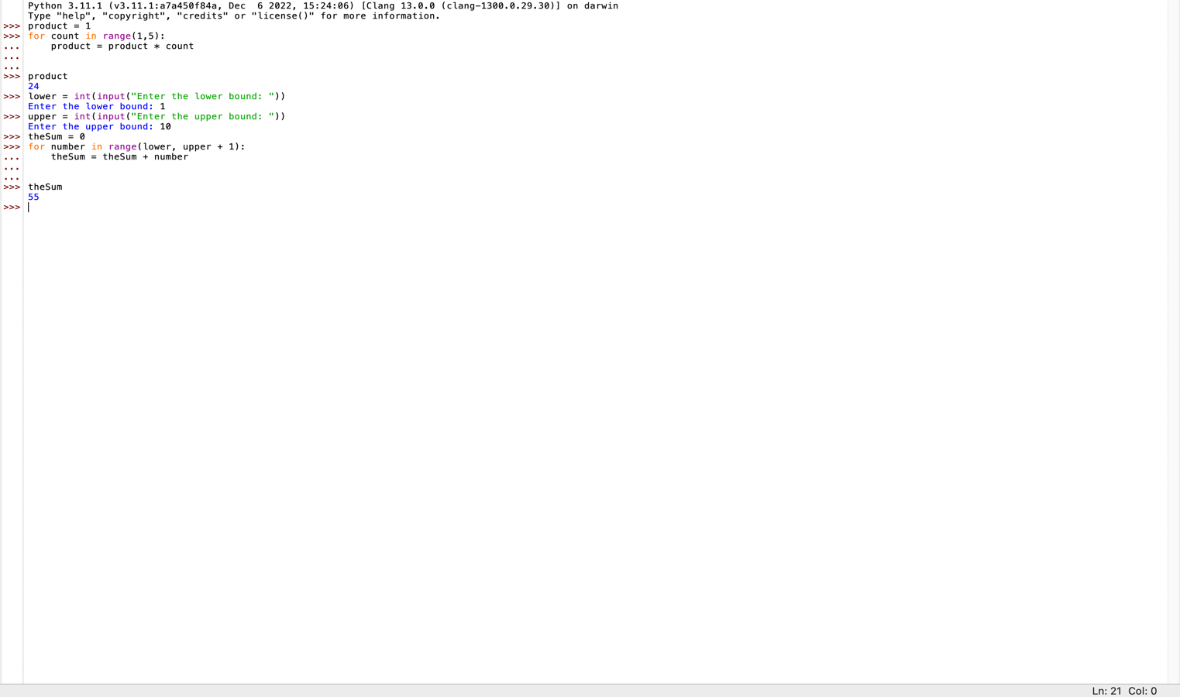

Pg. 68

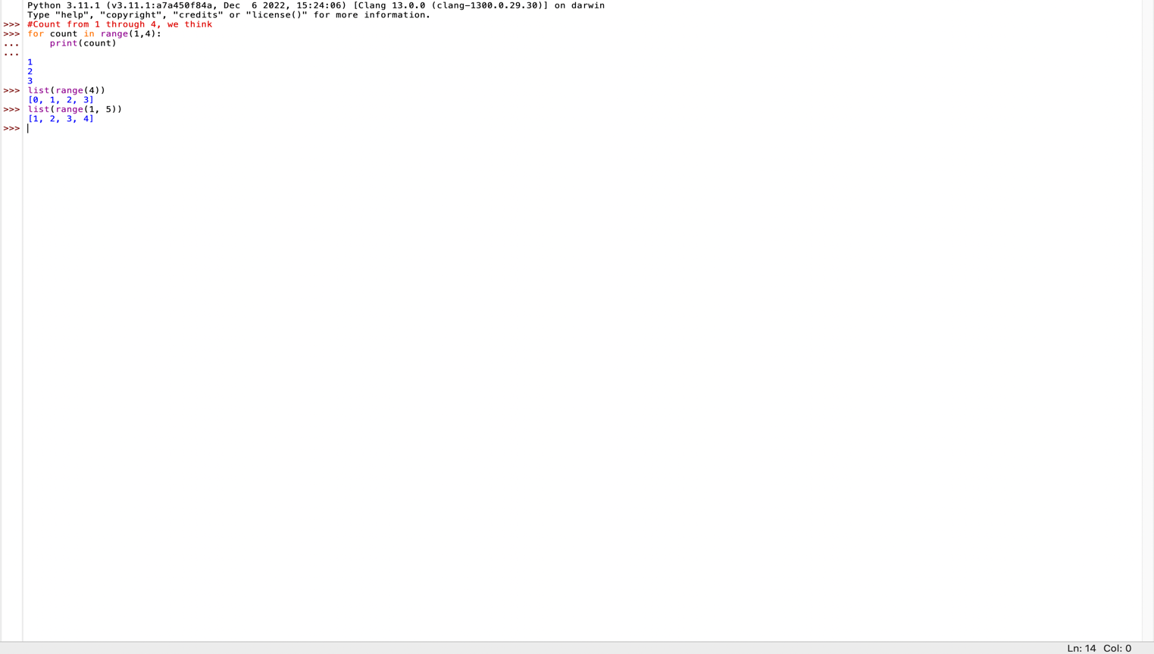

Pg 69.

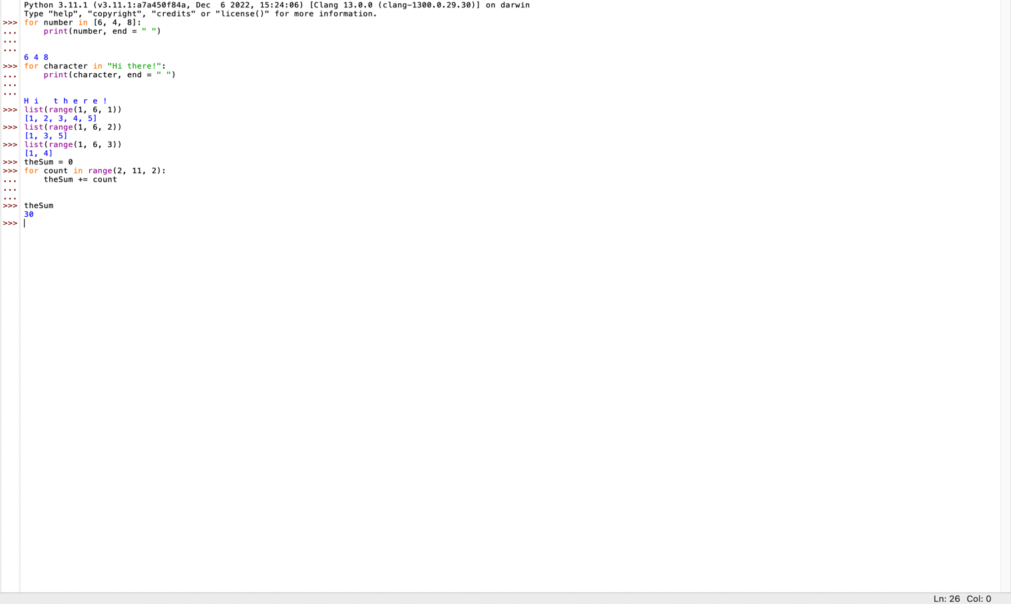

Pg 71.

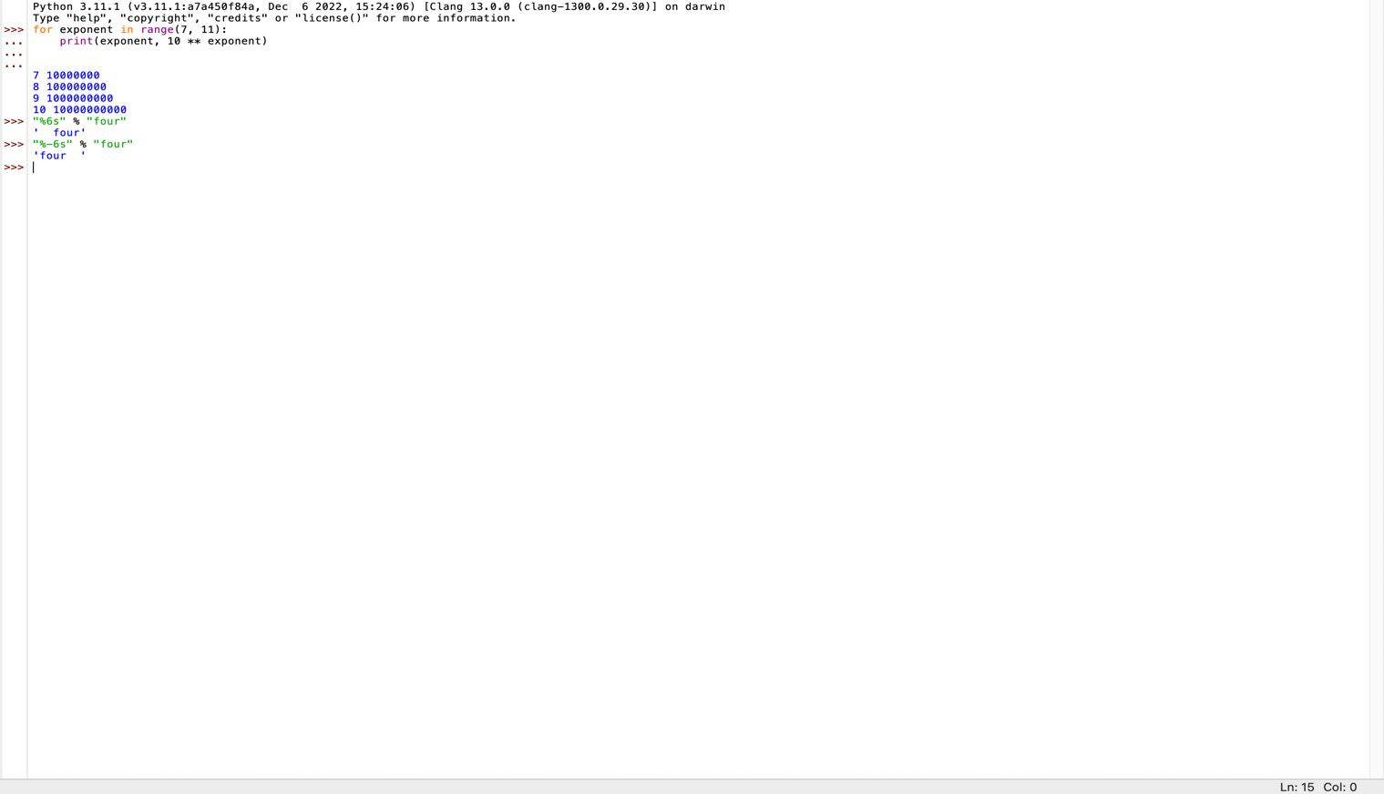

Pg. 72

